Experiment 1 :

Q1 :

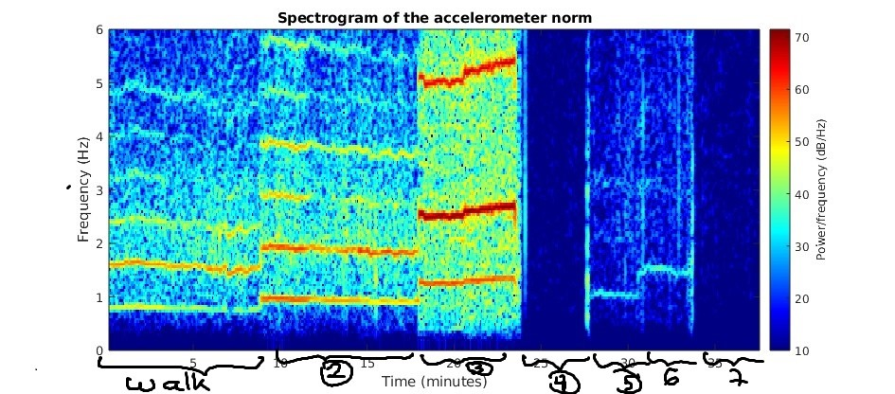

Q2 :

The minimal heart rate should be around 0.8Hz and the maximal around 1.2Hz.

Q3 :

While biking, the hand movement is very low and induces lower power frequency than running or walking which makes it easier to distinguish.

Q4 :

In the beginning of the fast running section, the watch is going to move a lot with the wrist which could compromise the signal registering.

Q5 :

The subject was walking 1.6Hz (96 steps per minute).

Experiment 2 :

Q1 :

We choose 25s because it is the period of the lowest frequency in the signal (1/0.04 = 25).

Q2 :

As most of the color we see is red/orange and there are a few yellowish tones, we put the lower value to -20.

Q3 :

At 2 hours, the LF-to-HF ratio is the higher. At 6 hours, the LF-to-HF ratio is the lower. At 4 hours, it is between the two previous ones.

Q4 :

No, we could not have concluded the same because the beat-to-beat mean seems to have approximately the same level at each of these time points.

Exercise :

Q1 :

The ideal value is the apnea time period (assuming it is bigger than the ventilation period). The minimal value is around 10s (60/8 = 10) and the maximal value is, as said before, 20s.